|  |  |  |  |  |
| --- | --- | --- | --- | --- |
|  | | | | |
| ***\** Details of Adult at Risk** | | | | |
| **Person ID:** |  | **Date Report Received:** |  | |
| **Title:** |  | **Full Name:** |  | |
| **Address:** |  | | | |
| **Home Tel No :** |  | **Mobile Tel No:** |  | |
| **Date of Birth:** |  | **Gender:** |  | |
| **Ethnicity** |  | **Religion:** |  | |
| **Preferred Language:** |  | **Interpreter Required?** | Yes  No | **Details:** |
| **GP Details** |  | | | |

***\**** Client Category of Need

|  |
| --- |
| Hearing Impairment |
| Learning Disability |
| Mental Health |
| Physical Disability |
| Older Person |
| Visual Impairment |
| Other (please specify) |

|  |  |  |  |  |
| --- | --- | --- | --- | --- |
| |  | | --- | | Any other adults/children at risk living at the property? | | |  | | --- | | Yes | | No | | |
| |  | | --- | | If Yes, what action has been taken? | | |  | | --- | |  | | |

|  |  |  |  |  |
| --- | --- | --- | --- | --- |
| **Abuse Details**  Primary category of abuse and details   |  |  | | --- | --- | | ***\** Primary Category of Abuse** | **Details** | | Physical  Sexual  Emotional/Psychological  Financial  Neglect  If selected, ‘Is the neglect self-inflicted?  Yes  No |  |   Are there any other type(s) of alleged abuse present |
| |  |  |  |  | | --- | --- | --- | --- | | |  | | --- | | Yes | | No | |  | |
| |  | | --- | | If Yes, please specify abuse type(s) |  |  |  | | --- | --- | | **Other Type(s) of Alleged Abuse** | **Details** | | Physical  Sexual  Emotional/Psychological  Financial  Neglect  If selected, ‘Is the neglect self-inflicted?  Yes  No |  | |

|  |  |  |  |  |  |  |
| --- | --- | --- | --- | --- | --- | --- |
| |  | | --- | | Was this identified as a result of Ask and Act? | | |  |  | | --- | --- | | Yes |  | | No |  | | |
| |  | | --- | | Has a DASH Assessment been completed? | | |  |  | | --- | --- | | Yes |  | | No |  | |  |  | | --- | | Describe what is happening? Please include a description of any injuries or harm? | | |  | | --- | |  | | |
| |  | | --- | | When/where did it occur? | | |  | | --- | | Date | | Time | | ***\** Location**  Care Home Setting  NHS Trust Group Home  Nursing Home  Residential Home  Supported living  Community  Alleged Person’s home  Public Place  Relative’s Home  Health Setting  Independent Hospital  NHS Hospital  Own Home  Other (please specify) | | |

|  |  |  |  |  |  |  |  |  |  |  |  |  |  |  |  |
| --- | --- | --- | --- | --- | --- | --- | --- | --- | --- | --- | --- | --- | --- | --- | --- |
| |  | | --- | | Has a body map been completed? | | |  |  | | --- | --- | | Yes |  | | No |  | | | If yes, is body map attached? | | |  |  | | --- | --- | | Yes |  | | No |  | |  |  | | --- | | What steps have been taken to safeguard/protect the individual and by whom?  (Include how the risk has been managed, what others have been informed – including statutory agencies, GP, Police, etc.)? | | |  | | --- | |  | | |
| |  | | --- | | Is there any evidence to suggest that the individual lacks mental capacity to consent/understand the concerns and/or process? | | |  | | --- | | Yes | | No | | Don't Know | | |
| |  | | --- | | Details (Please provide evidence to support your answer above) | | |  | | --- | |  | | |
| |  | | --- | | What are the individual’s views, wishes and feelings about the Safeguarding Concern?  (To include any actions they have taken or would like to be taken): | | |  | | --- | |  | |   Does the individual consent to the safeguarding report?   |  | | --- | | Yes | | No | | Don't Know | |

|  |  |  |  |  |  |  |  |  |  |  |  |  |  |  |  |  |
| --- | --- | --- | --- | --- | --- | --- | --- | --- | --- | --- | --- | --- | --- | --- | --- | --- |
| |  | | --- | | If no, why doesn’t the person consent to the Adult Safeguarding Process? | | |  | | --- | |  | |   If don’t know, please provide further information   |  | | --- | |  |  |  | | --- | | Next of Kin | | |  |  |  |  |  | | --- | --- | --- | --- | --- | | **Related Person** | **Inside Household** | **Relationship with Current Person** | **Start Date** | **End Date** | |  |  |  |  |  | | |

|  |
| --- |
| **Alleged Person’s Details** |
| ***\**** Is the alleged person known at this time |
| |  |  | | --- | --- | | Yes |  | | No |  | |

***\**** If Yes,

|  |  |  |  |  |  |  |  |  |
| --- | --- | --- | --- | --- | --- | --- | --- | --- |
| **Name** | **Relationship to Alleged Person** | **Address** | **Telephone** | **DOB** | **Do they have the capacity to understand their actions?** | **Does the alleged person provide Care & Support for the individual?** | **Does the alleged person have Care & Support needs?** | **Does the alleged person work with other adults or children?** |
| |  | | --- | |  | | |  | | --- | |  | | |  | | --- | |  | |  |  | |  | | --- | | Yes | | No | | Don't Know | | |  | | --- | | Yes | | No | | Don't Know | | |  | | --- | | Yes | | No | | Don't Know | | |  | | --- | | Yes | | No | | Don't Know | |

**ABOUT THE PERSON (S) WHO WITNESSED THE INCIDENT (S)**

|  |
| --- |
|  |
| |  |  |  |  |  |  |  |  |  |  |  |  | | --- | --- | --- | --- | --- | --- | --- | --- | --- | --- | --- | --- | | |  |  |  |  |  | | --- | --- | --- | --- | --- | | **Name** | **Relationship** | **Address** | **Telephone Number** | **Date of Birth** | |  |  | |  | | --- | |  | |  |  | | |

|  |  |  |  |  |  |  |  |
| --- | --- | --- | --- | --- | --- | --- | --- |
| |  |  | | --- | --- | | ***\** Person Reporting Details** | | | Incident reported by: | |  | |  | | --- | |  | | | |
| |  | | --- | | Completed By | |  | |  | | --- | |  | | |
| |  | | --- | | Date Completed | |  | |  |  |  |  |  | | --- | --- | --- | --- | --- | | DD |  | MM |  | YYYY | | |
| |  | | --- | | Job Title/Role | |  | |  | | --- | |  | | |
| |  | | --- | | Agency or Company | |  | |  | | --- | |  | | |
| |  | | --- | | Telephone Number | |  | |  | | --- | |  | | |
| |  | | --- | | Email Address | |  | |  | | --- | |  | | |

|  |  |  |  |
| --- | --- | --- | --- |
| |  | | --- | | ***\** REPORT RECEIVED FROM** | | |  | | --- | | Self  Relative  Friend or neighbour  Early intervention prevention service (Step-up)  Health  Education  Housing  Police  Probation  3rd Sector Organisation  Local Authority  Independent Hospital  Ambulance Service  Care Regulator  Provider  Advocate  Internal (Social Worker, Other Team)  Other | | |

|  |  |  |  |  |  |
| --- | --- | --- | --- | --- | --- |
| |  |  |  |  |  | | --- | --- | --- | --- | --- | | |  | | --- | | **Additional Information** | |  | |  | |  | | |

Form to be sent to:

**Blaenau Gwent:** [DutyTeamAdults@blaenau-gwent.gov.uk](mailto:DutyTeamAdults@blaenau-gwent.gov.uk)

01495 315700

**Caerphilly:** [asdit@caerphilly.gov.uk](mailto:asdit@caerphilly.gov.uk)  **or** [IAAAdults@caerphilly.gov.uk](mailto:IAAAdults@caerphilly.gov.uk)

0808 100 2500

**Monmouthshire:** [MCCadultsafeguarding@monmouthshire.gov.uk](mailto:MCCadultsafeguarding@monmouthshire.gov.uk)

01873 735492

**Newport:** [Pova.team@newport.gov.uk](mailto:Pova.team@newport.gov.uk) **or** [firstcontact.adults@newport.gov.uk](mailto:firstcontact.adults@newport.gov.uk)

01633 656656

**Torfaen:** [socialcarecalltorfaen@torfaen.gov.uk](mailto:socialcarecalltorfaen@torfaen.gov.uk)

01495 762200

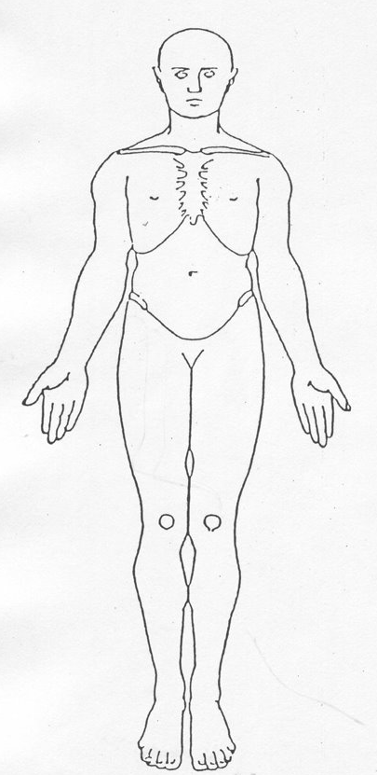 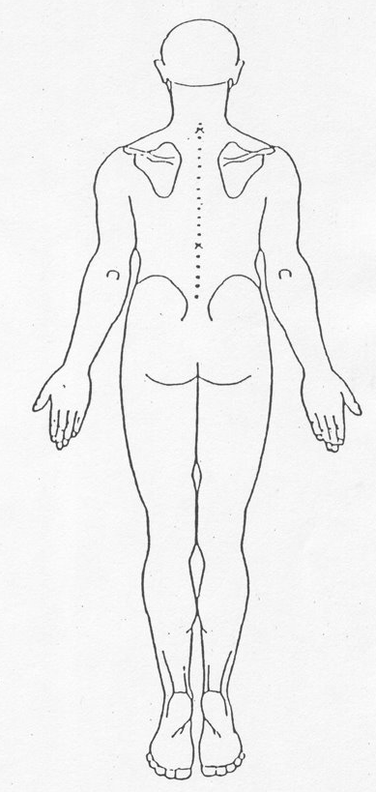

NB: This body map should only be completed if you are trained and competent at doing so. It is noted that any illustrations made are not to scale and for a guide only. Injuries can be described above in the **Abuse Details** Section.